**Exercise 2: E-commerce Platform Search Function**

**Code:**

import java.util.Arrays;  
import java.util.Comparator;  
  
class Product {  
 int productId;  
 String productName;  
 String category;  
  
 Product(int id, String name, String category) {  
 this.productId = id;  
 this.productName = name;  
 this.category = category;  
 }  
  
 public String toString() {  
 return productId + " | " + productName + " | " + category;  
 }  
}  
  
class Search {  
 public static Product linearSearch(Product[] p, int key) {  
 for (Product prod : p) {  
 if (prod.productId == key) {  
 return prod;  
 }  
 }  
 return null;  
 }  
  
 public static Product binarySearch(Product[] p, int key) {  
 int left = 0, right = p.length - 1;  
 while (left <= right) {  
 int mid = (left + right) / 2;  
 if (p[mid].productId == key)  
 return p[mid];  
 else if (p[mid].productId < key)  
 left = mid + 1;  
 else  
 right = mid - 1;  
 }  
 return null;  
 }  
}  
  
public class Main {  
 public static void main(String[] args) {  
 Product[] p = {  
 new Product(103, "Laptop", "Electronics"),  
 new Product(102, "Mobile", "Electronics"),  
 new Product(101, "Pen", "Stationary")  
 };  
  
 Arrays.*sort*(p, Comparator.*comparing*(p2 -> p2.productId));  
  
 for (Product p1 : p) {  
 System.*out*.println(p1);  
 }  
  
 Product result1 = Search.*linearSearch*(p, 102);  
 if (result1 != null) {  
 System.*out*.println(result1);  
 } else {  
 System.*out*.println("Not Found");  
 }  
  
 Product result2 = Search.*binarySearch*(p, 102);  
 if (result2 != null) {  
 System.*out*.println(result2);  
 } else {  
 System.*out*.println("Not Found");  
 }  
 }  
}

**Output:**

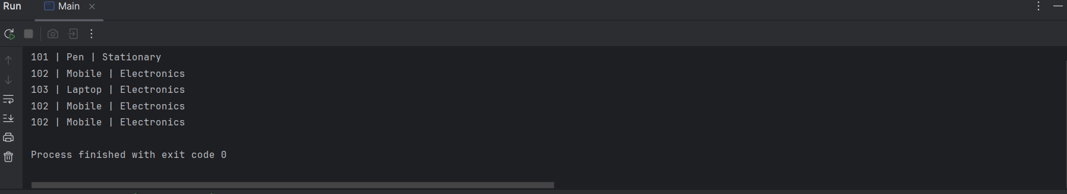

**Exercise 7: Financial Forecasting**

**Code:**

import java.util.Scanner;  
  
public class Main {  
 public static double predict(double p, double r, int y) {  
 if (y == 0) {  
 return p;  
 } else {  
 return *predict*(p, r, y - 1) * (1 + r);  
 }  
 }  
 public static void main(String[] args) {  
 Scanner sc = new Scanner(System.*in*);  
  
 System.*out*.print("initial amount: ");  
 double amount = sc.nextDouble();  
  
 System.*out*.print("annual growth rate: ");  
 double rate = sc.nextDouble();  
  
 System.*out*.print("number of years: ");  
 int time = sc.nextInt();  
  
 double result = *predict*(amount, rate, time);  
  
 System.*out*.printf("future value after %d years:Rs. %.2f", time, result);  
  
 }  
}

**Output:**

